HOW TO REGISTER GUIDE
Summer 2021

Professional Development students register on the College’s LMS – LEO – Lake Erie Online https://leo.lec.edu/ICS/Summer_2021_Prof_Development_Term/

- “READ Updates Please”.
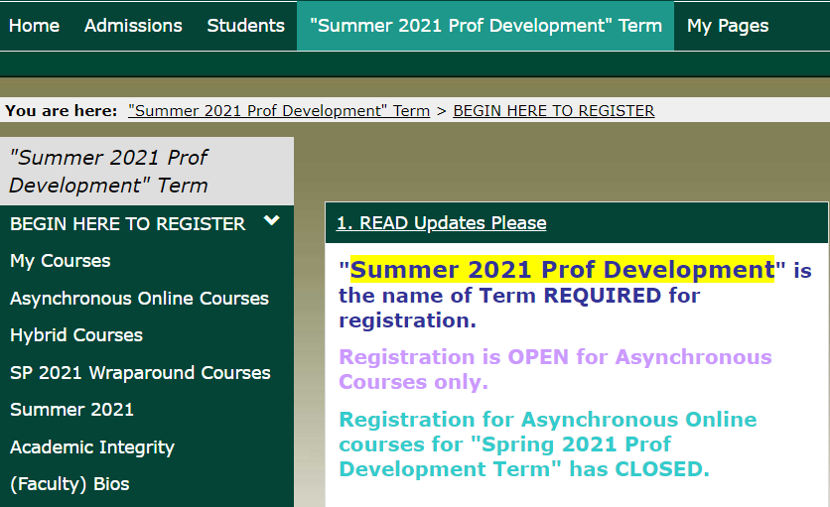

- Don’t have a Username and Password? Or forgot it? Click “3. Create LEO Account”.
Have a LEO Account? Skip to #5 of these instructions on page 2.
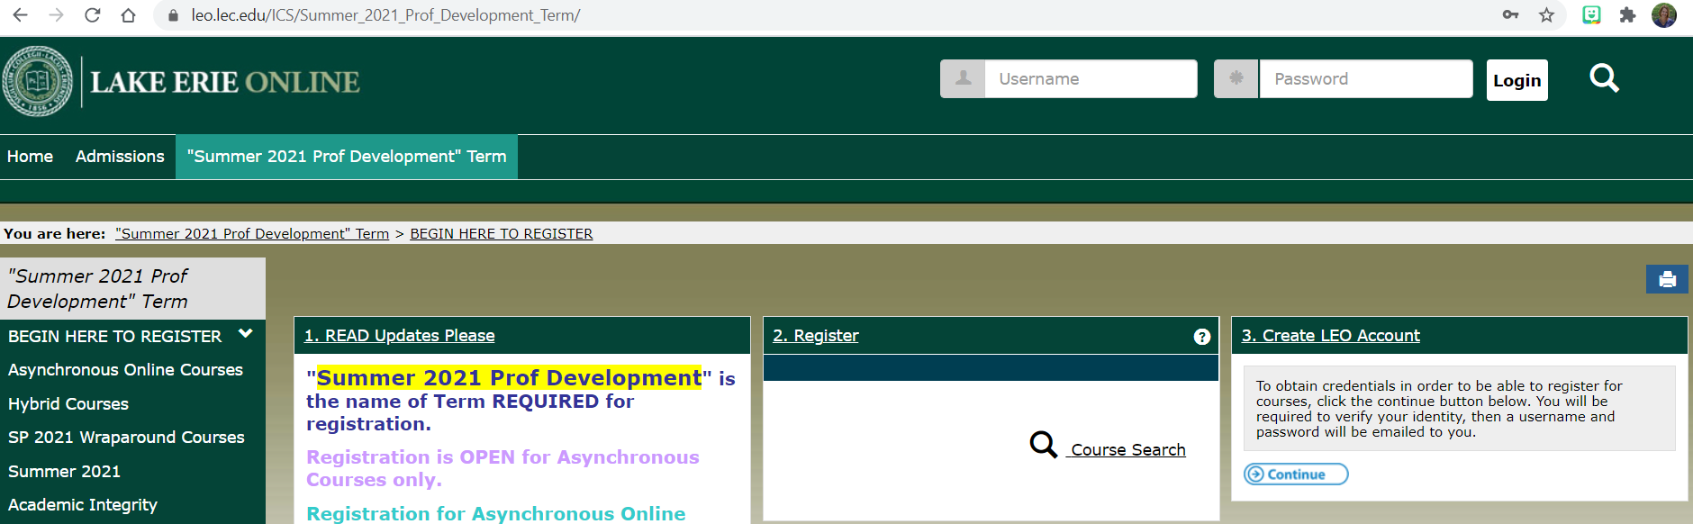

- Click “Continue”

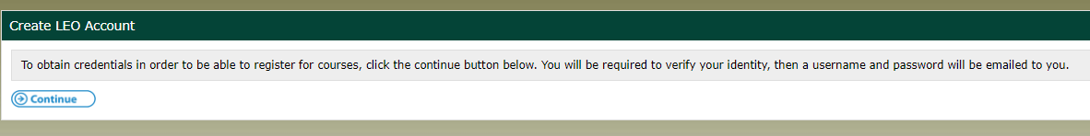

- Complete all fields, click “Continue”.
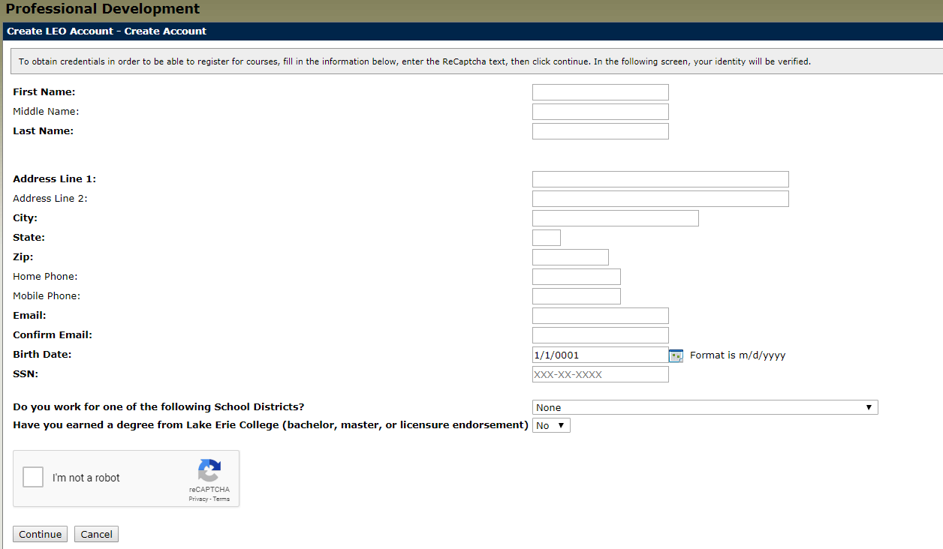If your birth date is single digit day and month do NOT add the zero (e.g. 1/9/1983 is the proper formatting) Please note the system will default with today’s date. It is CRITICAL to provide your birthdate or the system will assign you a new ID even if you’d taken classes previously.

If the system is frozen after clicking “I’m not a robot” and “Continue” contact the office at 440-375-7379. This may happen if you were an undergraduate or completed a MEd, Endorsement or MMIS work at LEC.

This should be the next screen you automatically see.
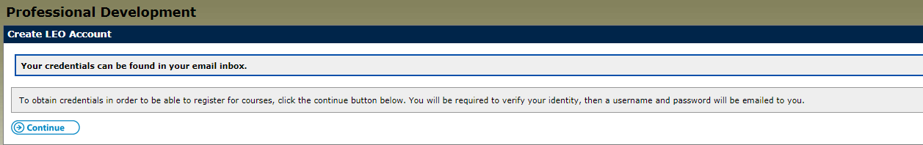

- Access your email (whichever you provided in the Create LEO Account fields). CHECK YOUR SPAM and JUNK folder if you don’t see it. It is sent from noreply@lec.edu.

It will say, “The following credentials may be used in order to log into your account”.
xxxxxx (Username-all numerals-NEVER CHANGES)
xxxxxxx (Password-mix of letters, numerals, special symbols-CASE SENSITIVE-Can be changed. See step #18)

- Type Username and Password at top of screen, click “Login”.

- The system will default to Home..ALWAYS click on Summer 2021 Prof Development tab.
- Click “#2 Register” select “Summer 2021 Prof Development” as the Term.
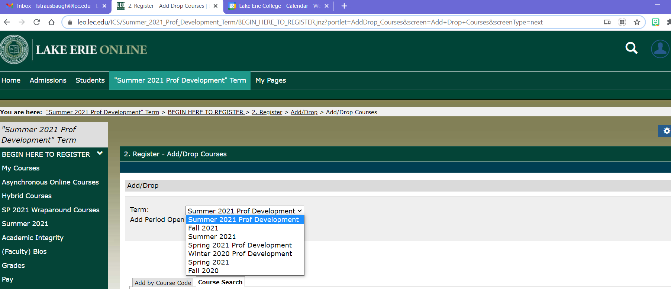

- Click “Add by Course Code” instead of using “Course Search” function.

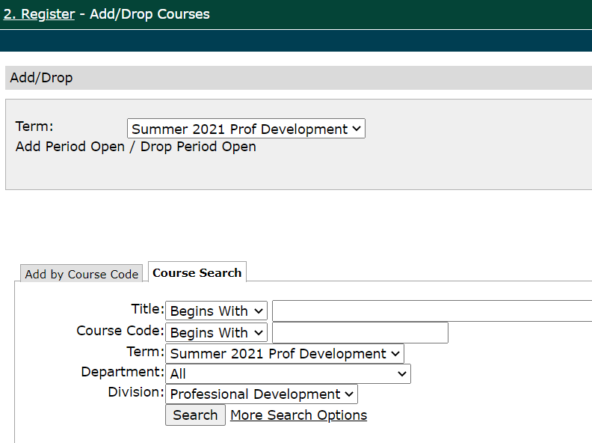 then it will appear 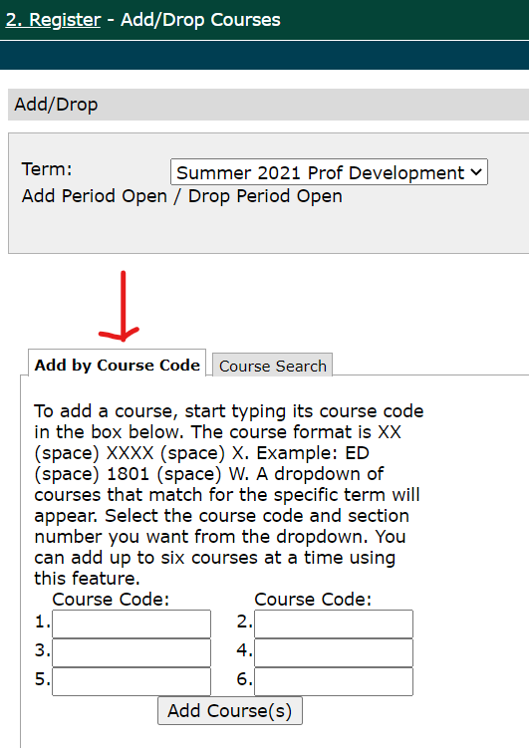

- Type course code in box. All PD courses are formatted: ED (space) xxxx and W.
- Then click 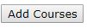
- You will select how you want to be graded using the Variable Grading Type except if you are enrolling in a Wraparound course; they are always taken pass/fail.

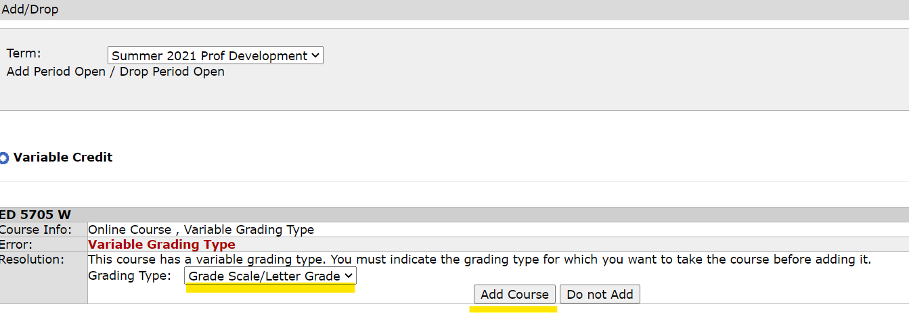

“The Drop Period is closed” means only the Director can drop a course.
- The system will review your selection. Next click “Pay Must Pay Courses”.
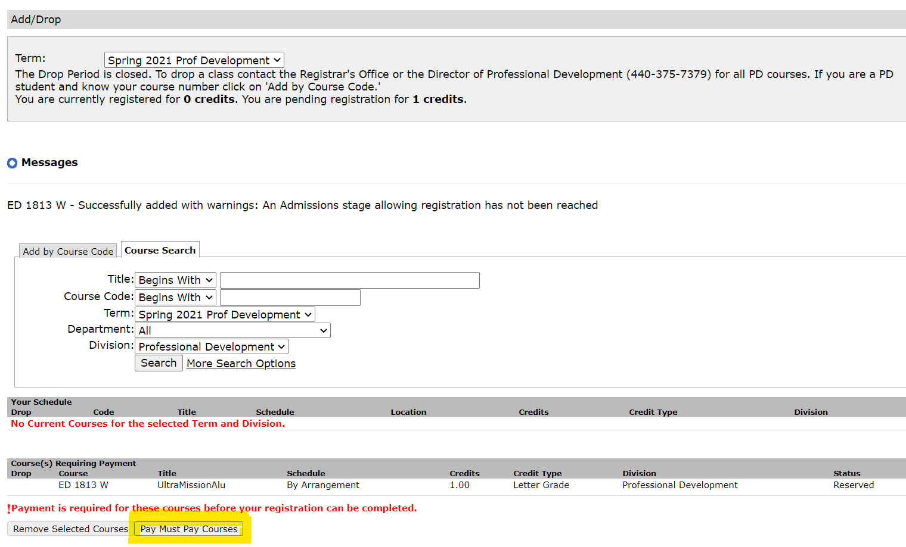
- Bill will run

- Click “Pay Now”.
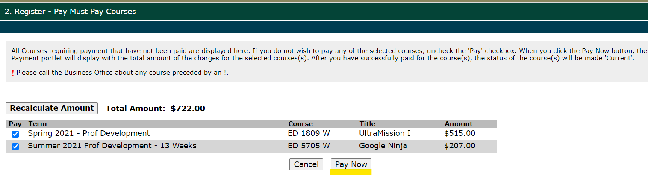
- Choose Credit Card or E-Check and Click “Continue”.

- Complete all fields, “Continue”.

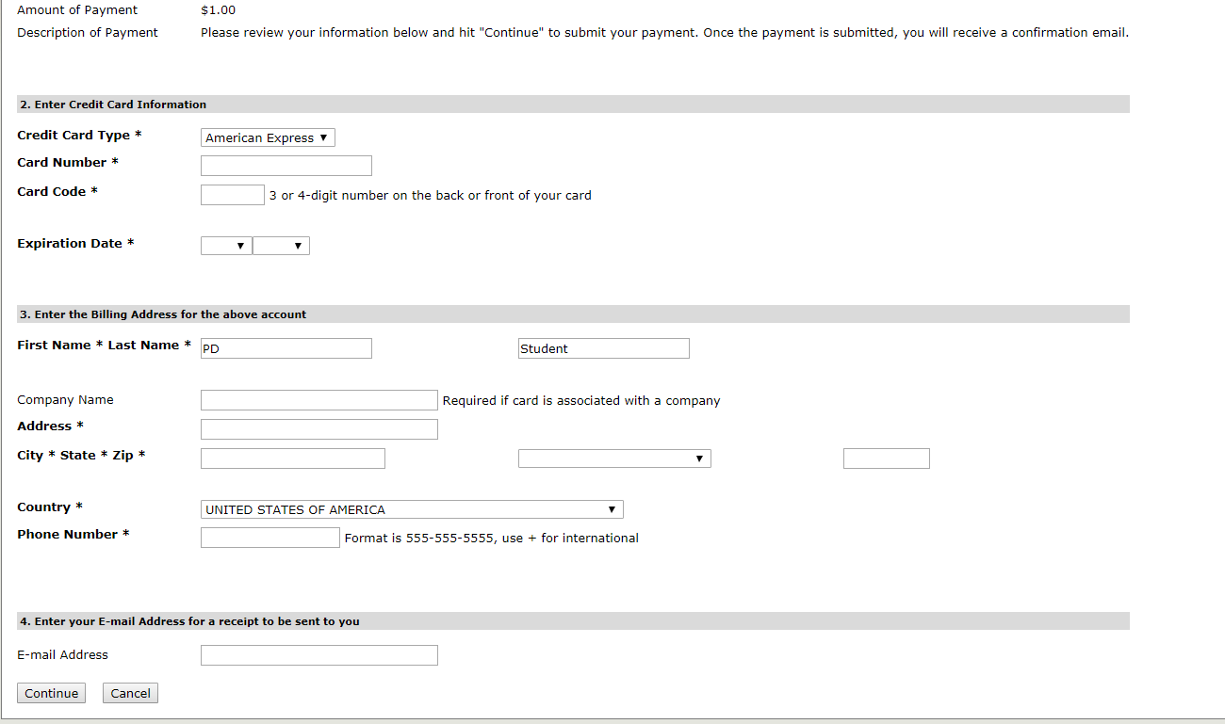

- Once the payment has been applied you will immediately receive an email from noreply@mail.authorize.net titled "Merchant Email Receipt" (the email will not list the courses registered only the tuition paid).

- You will receive a registration confirmation email from the Registrar’s Office sent from prodel@lec.edu with 24 business hours Monday-Thursday of registration. If you register late Friday-Sunday you will receive the confirmation on Monday.
- To change your password: log in, click on silhouette in blue, click on “My profile & settings”. You’ll see Welcome back and your name. 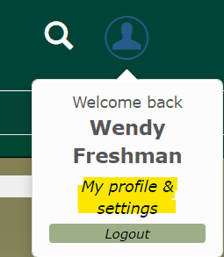

Click on “Password & privacy”, then click on “Change password”.
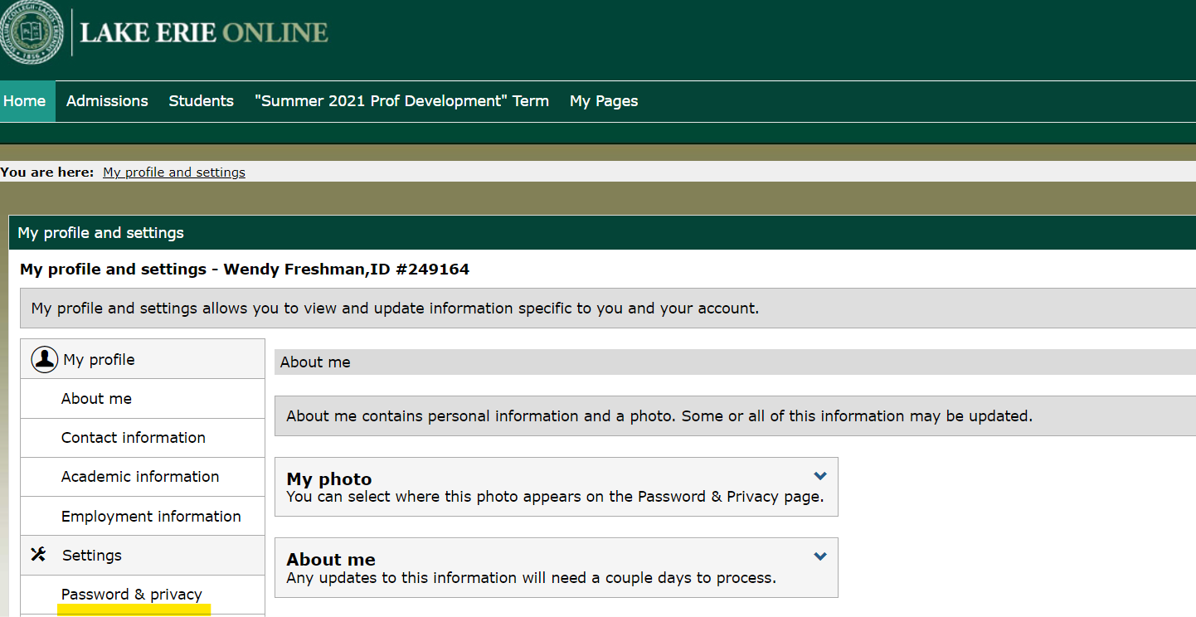
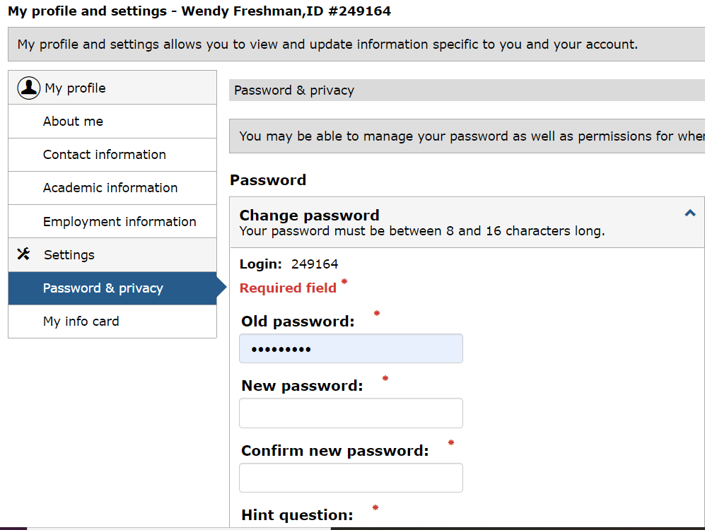
Type in Old password and new one twice. Make sure to SAVE!
Call the Director of Professional Development for assistance at 440-375-7379.

