HOW TO REGISTER GUIDE
“SP 2022 Prof Development” Term

Professional Development students register on the College’s LMS – LEO – Lake Erie Online https://leo.lec.edu/ICS/SP_2022_Prof_Development/

- “READ Updates Please”.
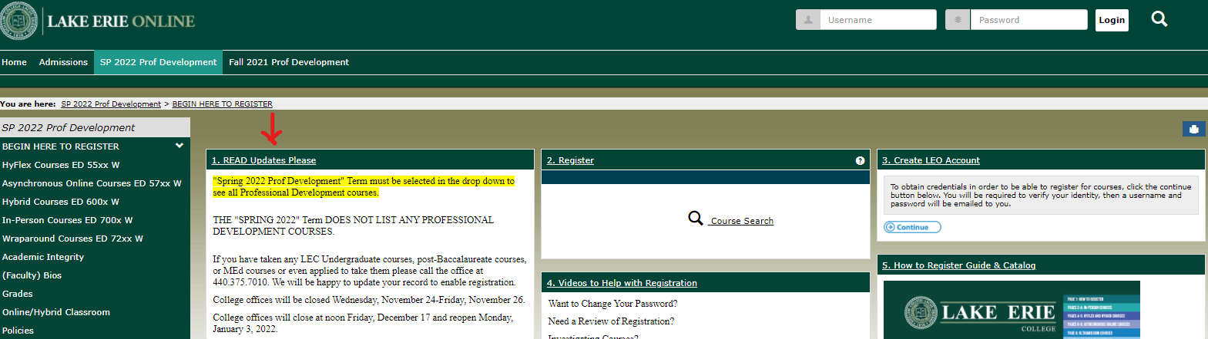

- Don’t have a Username and Password? Or forgot it? Click “3. Create LEO Account”. Click “Continue”.
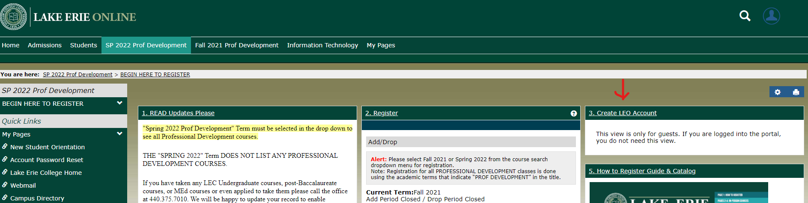

Have a LEO Account? Skip to #5 of these instructions on page 2.

- Complete all fields, click “Continue”.
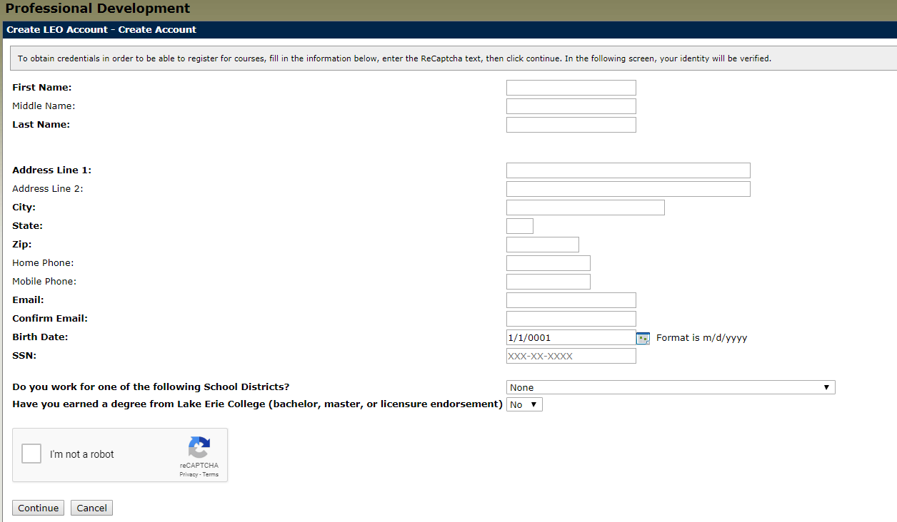If your birth date is single digit day and month do NOT add the zero (e.g. 1/9/1983 is the proper formatting) Please note the system will default with today’s date. It is CRITICAL to provide your birthdate or the system will assign you a new ID even if you’d taken classes previously.

If the system is frozen after clicking “I’m not a robot” and “Continue” contact the office at 440-375-7379. This may happen if you were an undergraduate or completed a MEd, Endorsement or MMIS work at LEC.

This should be the next screen you automatically see.
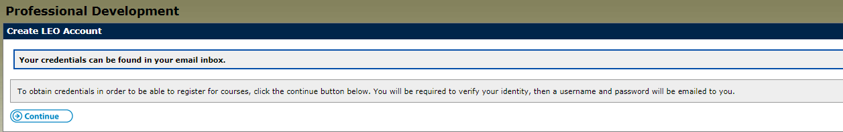

4. Access your email (whichever you provided in the Create LEO Account fields). CHECK YOUR SPAM folder if you don’t see it. It is sent from noreply@lec.edu.

It will say, “The following credentials may be used in order to log into your account”.
xxxxxx (Username-all numerals-NEVER CHANGES)
xxxxxxx (Password-mix of letters, numerals, special symbols-CASE SENSITIVE-Can be changed. See step #18)

5.Type Username and Password at top of screen, click “Login”. The system will default to Home..ALWAYS click on “SP 2022 Prof Development” tab.

- Within “2. Register” in center of your screen click “Add/Drop Courses”.
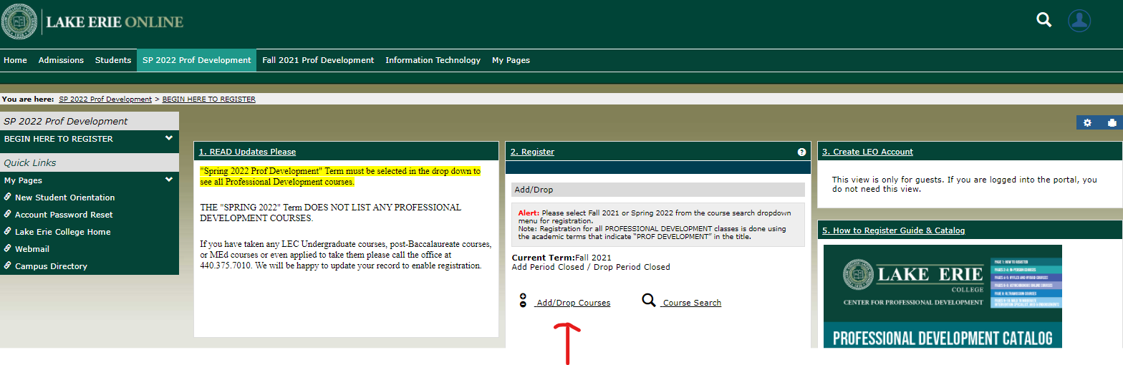

- Change the Term to Spring 2022 Prof Development.

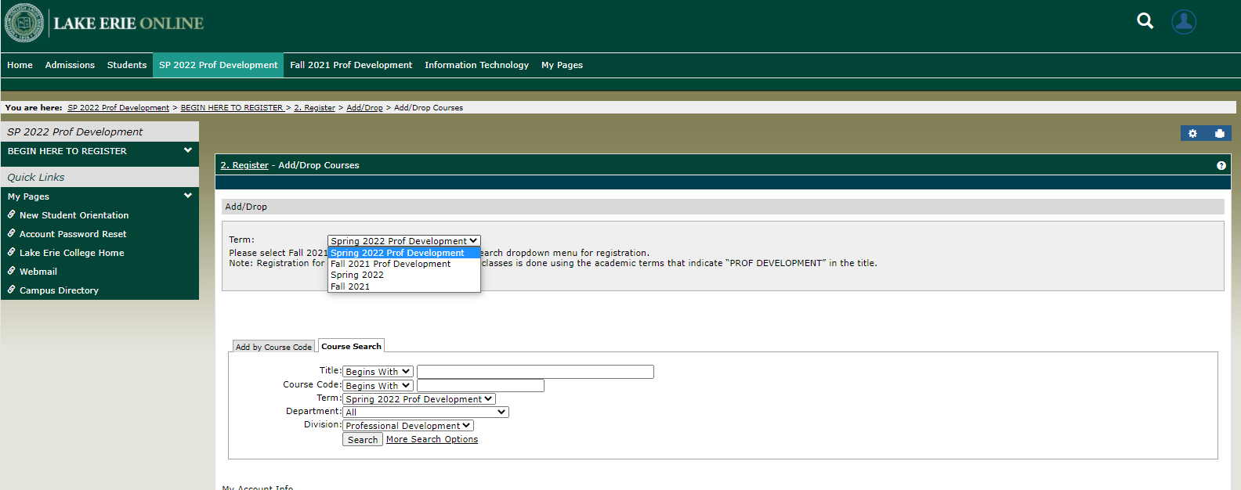

- Click “Add by Course Code” NOT “Course Search” function.

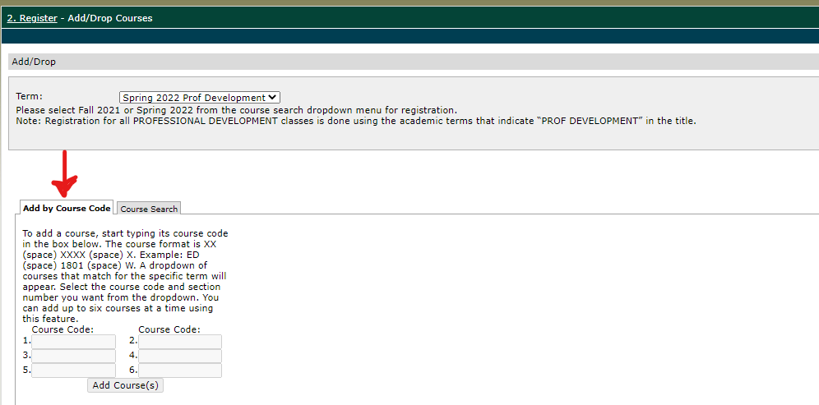

- Type course code in box. All PD courses are formatted: ED (space) xxxx and W.
- Then click 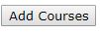
- You will select how you want to be graded using the Variable Grading Type except if you are enrolling in a Wraparound course; they are always taken pass/fail.

“The Drop Period is closed” means only the College can drop a course.

- The system will review your selection. Next click “Pay Must Pay Courses”.

- Bill will run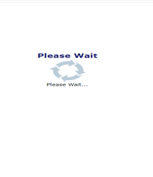

- Click “Pay Now”.

- Choose Credit Card or E-Check and Click “Continue”.

- Complete all fields, “Continue”.

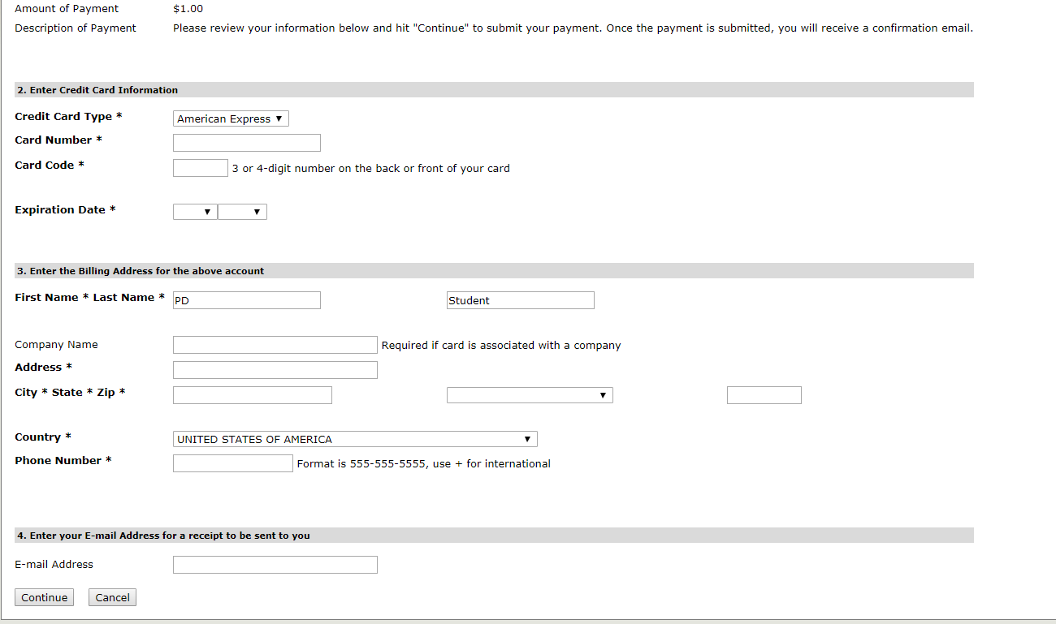

- Once the payment has been applied you will immediately receive an email from noreply@mail.authorize.net titled "Merchant Email Receipt" (the email will not list the courses registered only the tuition paid).

- You will receive a registration confirmation email from the Registrar’s Office sent from prodel@lec.edu with 24 business hours Monday-Friday confirming the exact course you selected. Your adjunct will be copied on that communication.

18. To change your password: log in, click on silhouette in blue, click on “My profile & settings”. You’ll see Welcome back and your name. 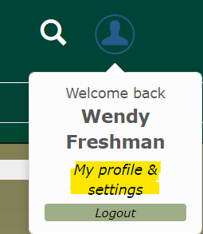

Click on “Password & privacy”, then click on “Change password”.
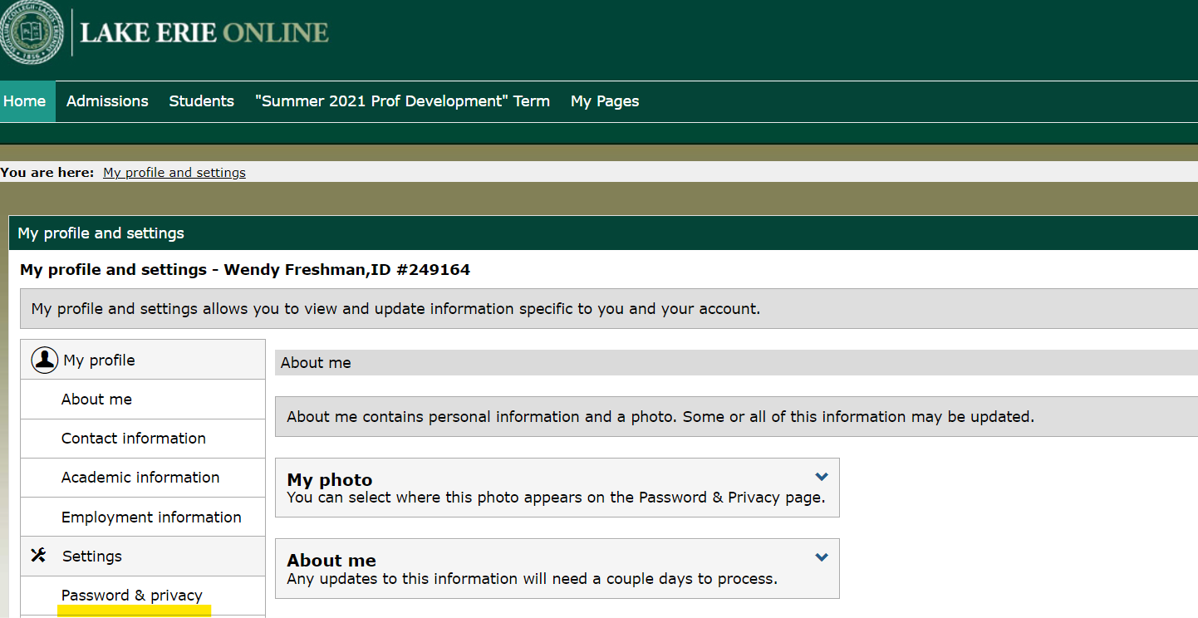
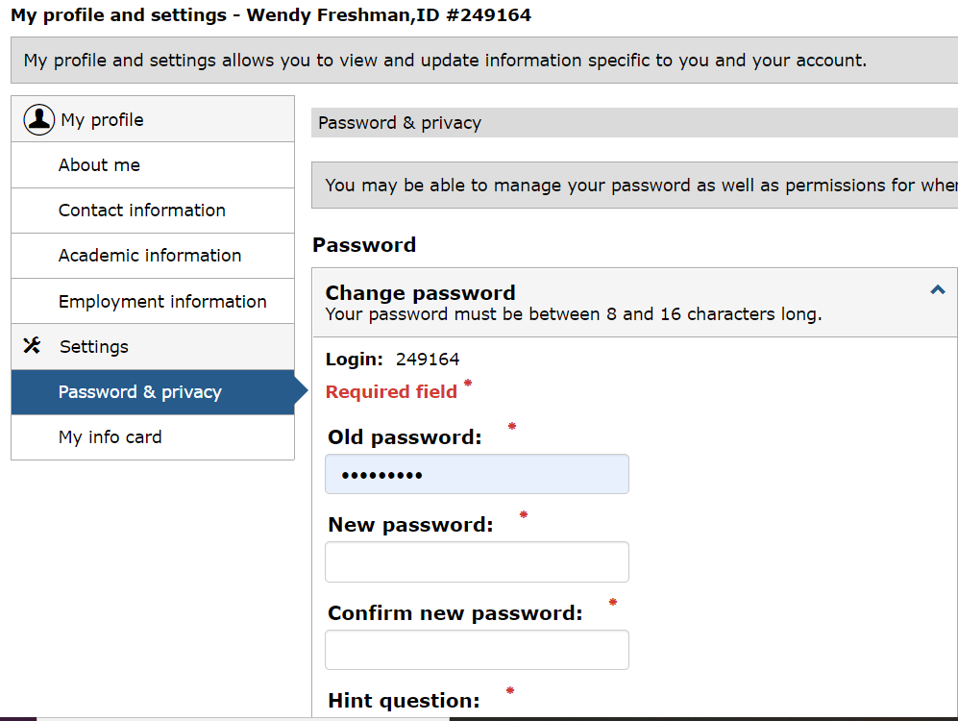
Type in Old password and new one twice. Make sure to SAVE!
Call the College for assistance at 440-375-7379.

