HOW TO REGISTER GUIDE
Fall 2020

Professional Development students register on the College’s LMS – LEO – Lake Erie Online https://leo.lec.edu/ICS/Professional_Development/

- Don’t have a Username and Password? Or forgot it? Click “BEGIN HERE” dropdown, click “Create LEO Account”. Have a LEO Account? Skip to #5. Everyone please Read “Updates” under the BEGIN HERE TO REGISTER dropdown.
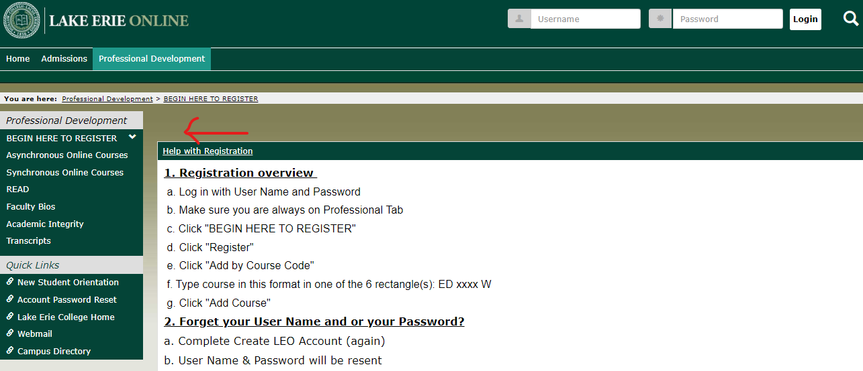

- Click “Continue”

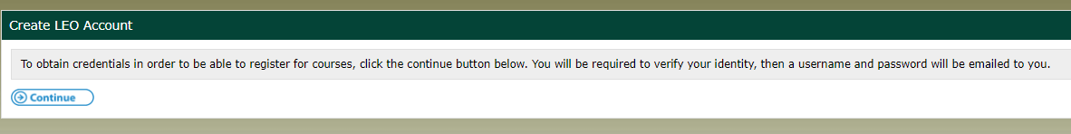

- Complete all fields, click “Continue”.
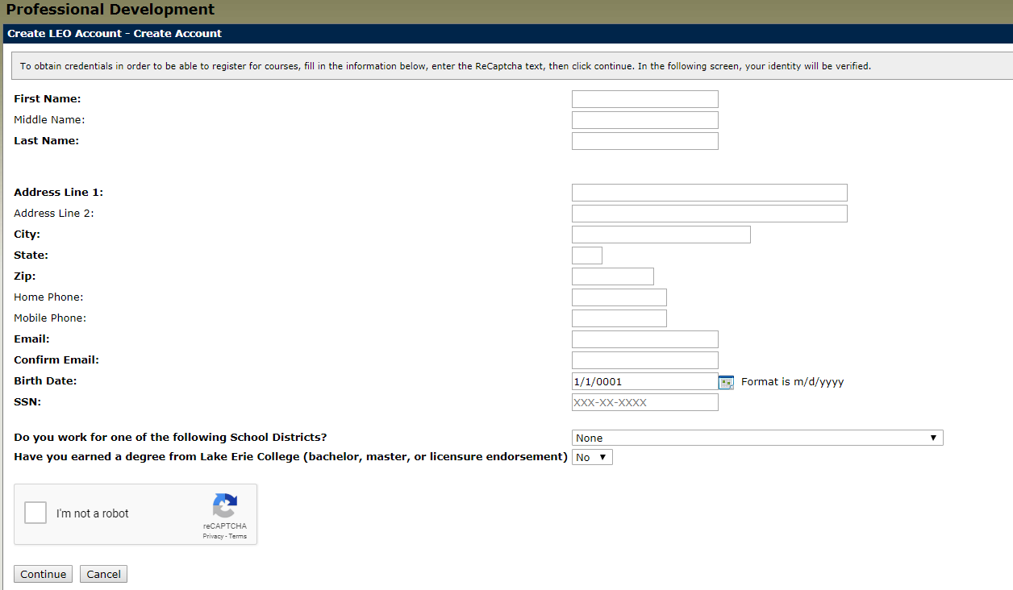If your birth date is single digit day and month do NOT add the zero (e.g. 1/9/1983 is the proper formatting) Please note the system will default with today’s date .. it is CRITICAL to provide your birthdate or the system will assign you a new ID even if you’d taken classes previously.

If the system is frozen after clicking “I’m not a robot” and “Continue” contact the office at lstrausbaugh@lec.edu or 440-375-7379. This may happen if you were an undergraduate or completed a MEd, Endorsement or MMIS work at LEC.

This should be the next screen you automatically see.
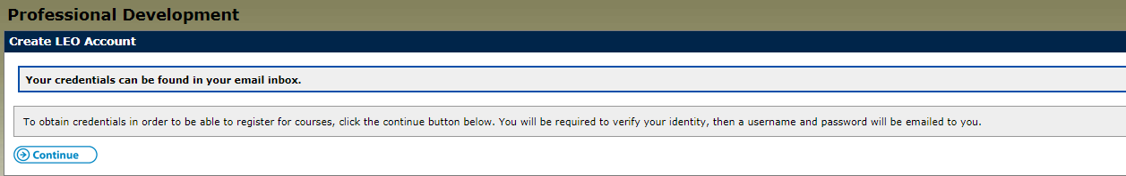

- Access your email (whichever you provided in the Create LEO Account fields). CHECK YOUR SPAM and JUNK folder if you don’t see it. It is sent from noreply@lec.edu.

It will say, “The following credentials may be used in order to log into your account”.
xxxxxx (Username-all numerals-NEVER CHANGES)
xxxxxxx (Password-mix of letters, numerals, special symbols-CASE SENSITIVE-Can Be Changed)

- Type Username and Password at top of screen, click “Login”.

- The system will default to Home..ALWAYS click on Professional Development tab.

- Click “BEGIN HERE” dropdown to see Register, click and you’ll see Add/Drop Courses. Make sure Term is Fall 2020.

- Click “Add by Course Code”

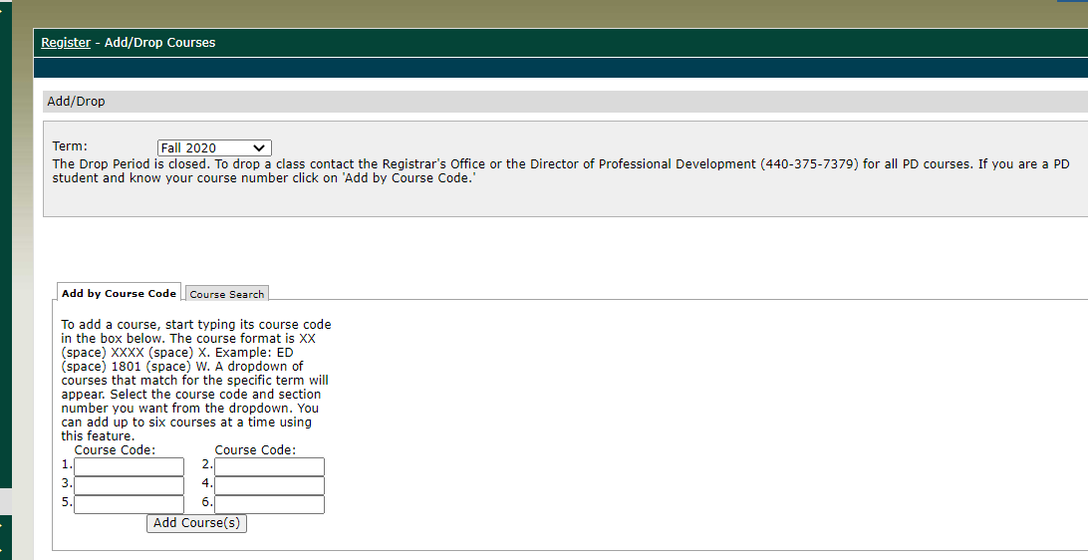

- Type course code in box. All PD courses are formatted: ED (space) xxxx and W.
- Then click 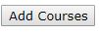
- You will select how you want to be graded in LEO except if you are enrolling in a Wraparound course; they are always taken pass/fail.
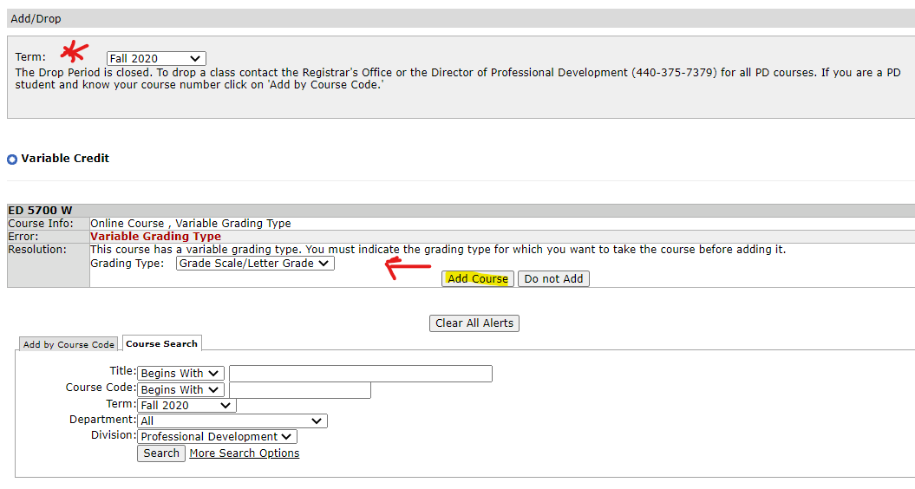

*”The drop period is closed” is indicated; only the Director can drop a course if you registered in error.

- The system will review your selection. Next click “Pay Must Pay Courses”. 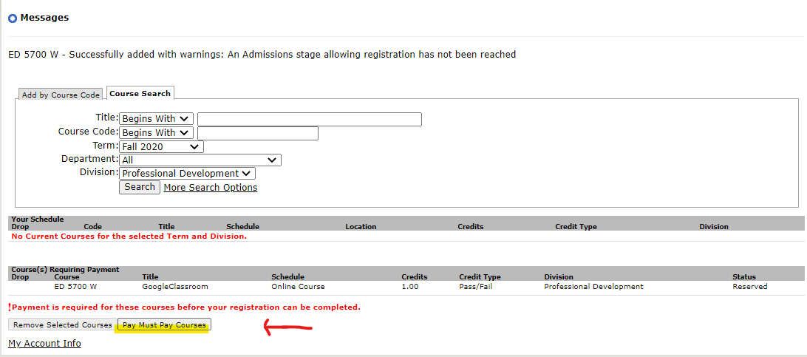
- Bill will run

- Click “Pay Now”, Choose Credit or E-check, “Continue”, Complete all fields, “Continue”
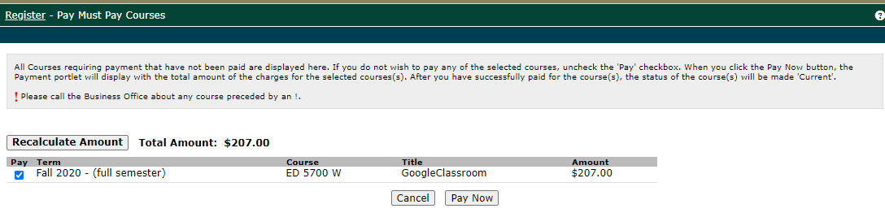

Choose Credit Card or E-Check and Click “Continue”.
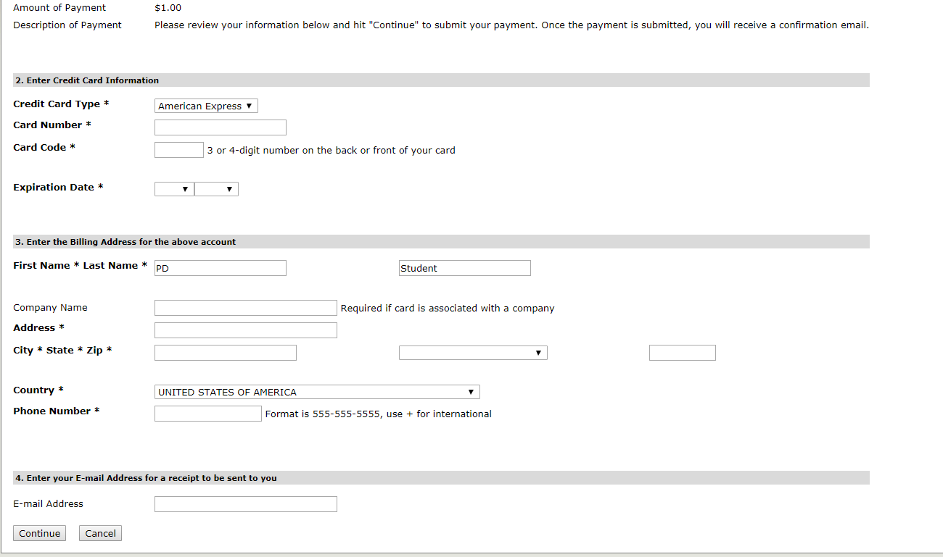

Once the payment has been applied you will immediately receive an email from noreply@mail.authorize.net titled "Merchant Email Receipt" (the email will not list the courses registered only the tuition paid).

You will receive a registration confirmation email from the Registrar’s Office sent from prodel@lec.edu with 24 business hours Monday-Thursday of registration. If you register late Friday-Sunday you will receive the confirmation on Monday.

Call Lisa Strausbaugh, Director of Professional Development for assistance at 440-375-7379 or lstrausbaugh@lec.edu.

