HOW TO REGISTER GUIDE – Fall 2019
(updated August 7, 2019)

Professional Development students register on the College’s portal – LEO – Lake Erie Online - direct link https://leo.lec.edu/ICS/Professional_Development/

Click “Create LEO Account” if you don’t already have a User Name and Password for LEO (even if you have taken courses in the past).
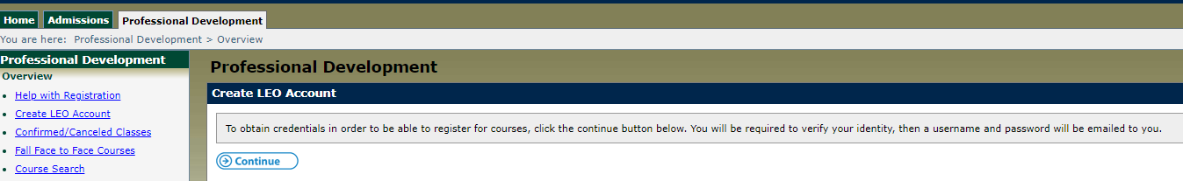

Click “Continue” button

Complete all fields
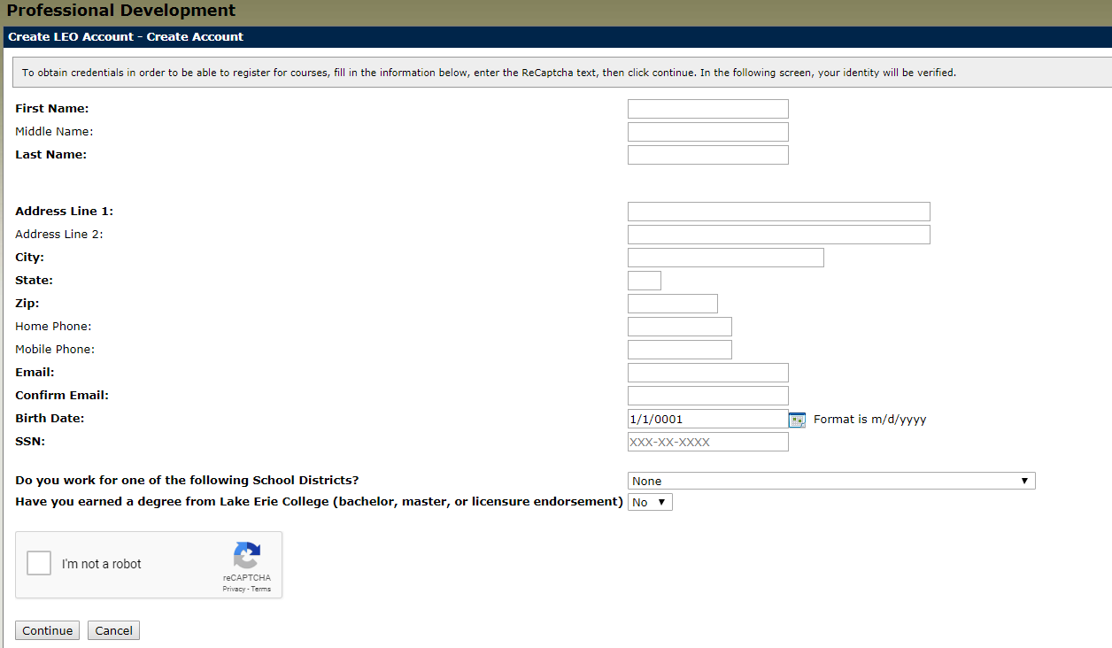
If your birth date is single digit day and month do NOT add the zero (e.g. 1/9/1983 is the proper formatting)

If the system is frozen after clicking “I’m not a robot” and “Continue” contact the office at lstrausbaugh@lec.edu or 440-375-7379. This may happen if you were an undergrad. or masters student previously.

This should be the next screen you automatically see.
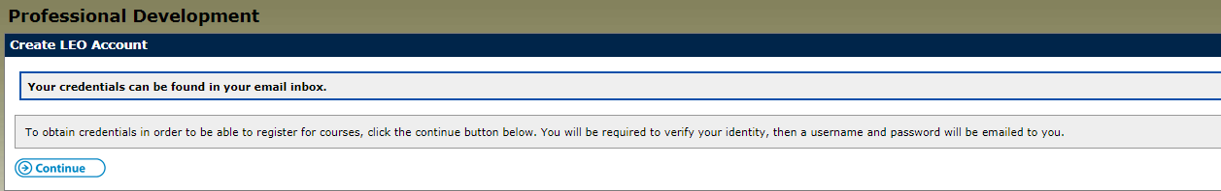

Open a new tab to log into your email (whichever you provided in the form). CHECK YOUR SPAM and JUNK folder if you don’t see it. It is sent from noreply@lec.edu.

It will say, “The following credentials may be used in order to log into your account”.

xxxxxx (User Name-all numerals)
xxxxxxx (Password-mix of letters, numerals, special symbols-CASE SENSITIVE)

Use the User Name and Password provided to log in and NOW you will see new categories on the Professional Development tab.

Click “Register”.

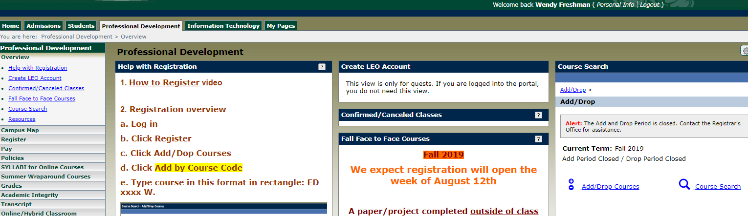

Click “Add/Drop Courses”
Click “Add by Course Code”

Add course(s) in rectangles below.

All PD courses are formatted: ED (space) xxxx and W
(for example ED 7009 W)

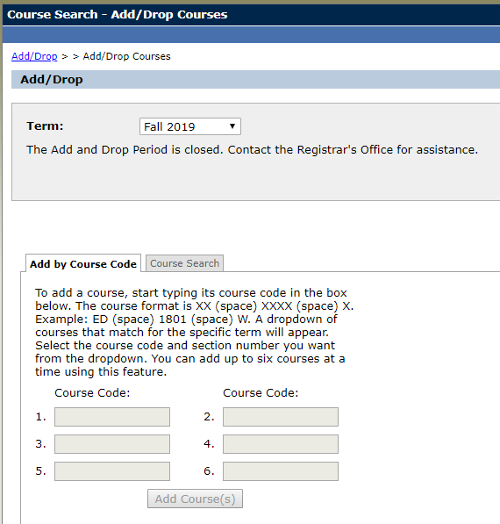

Then click 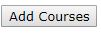

If you enrolled in an Online or Ultramission course you will select how you want to be graded.
Wraparounds are always pass/fail.
You will decide how to be graded for Face to Face Courses on Day One of class. (The system will default as Letter Grade)
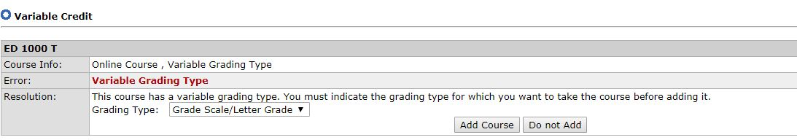

To drop a course you MUST contact the Director.
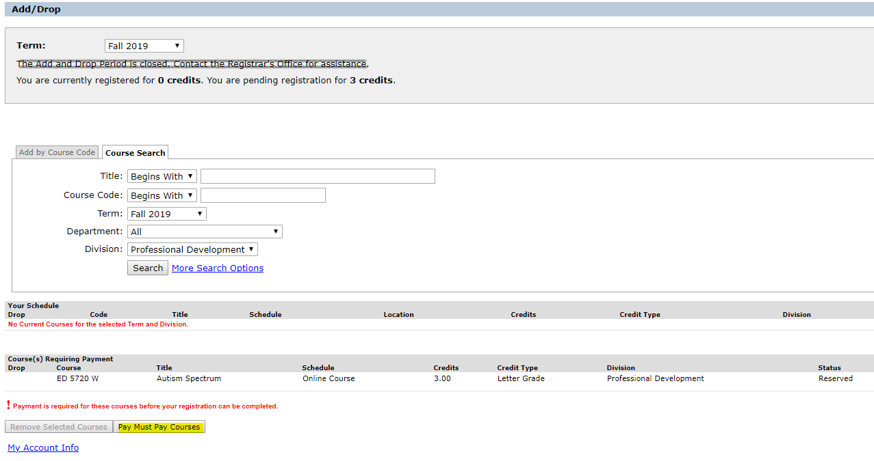

Click “Pay Must Pay Courses”. A bill will be run you’ll see something like this:
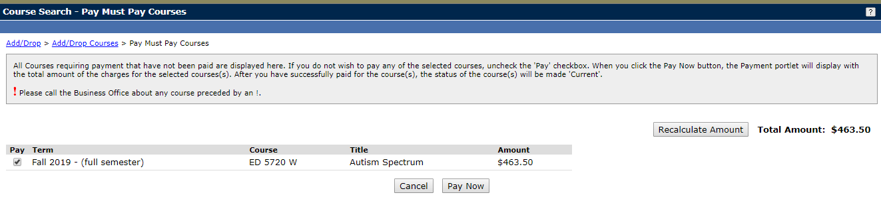
Click “Pay Now”.

Choose Credit Card or E-Check and Click “Continue”.
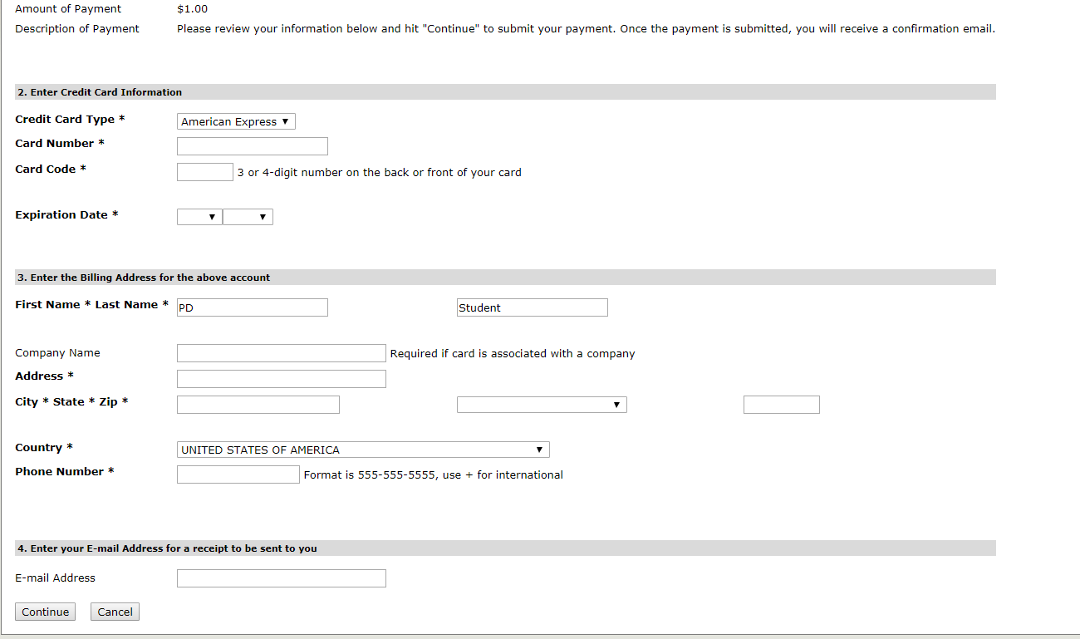
Click “Continue”

Once the payment has been applied you will immediately receive an email from noreply@mail.authorize.net titled "Merchant Email Receipt" (the email will not list the courses registered only the tuition paid).

REVIEW:
Click “Pay” to view your bill, course and fee statement.
Click “Policies” for further information.
Click “SYLLABI for Online Courses for a numerical list and syllabi links.
Click “Grades" to see posted grades and or download an unofficial transcript.
Click “Academic Integrity” to view College policies with regard to plagiarism etc.
Click “Transcript” to request additional official transcripts (electronic or paper).

You can see your courses in “Your Course Schedule”, click on course ED xxxx W for the course description, enrollment, location, faculty email etc.

You will receive a registration confirmation email from the Registrar’s Office sent from prodel@lec.edu with 24 business hours Monday-Thursday of registration. If you register late Friday-Sunday you will receive the confirmation on Monday.

Call Lisa Strausbaugh, Director of Professional Development for assistance at 440-375-7379 or lstrausbaugh@lec.edu.

