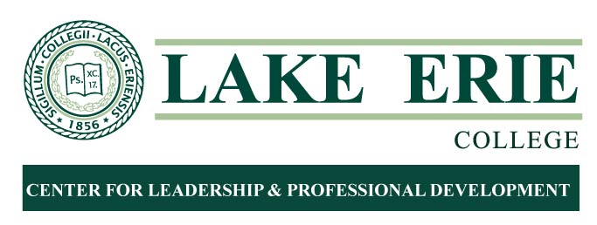

Berkshire Schools Standard Based Grading
ED 7202 W
Spring 2020

Course Description: Guided by Envison Ed Plus, elementary teachers in grades K-5 will meet for multiple full, 1/2, and partial days during the 2019-2020 school year to collaboratively prepare for standards based grading and assessment starting in the 2019-2020 school year. Preparing for standards based grading and assessment includes sessions based on deconstructing standards, designating power standards, creating standards-based report cards, creating rubrics aligned to the standards, creating parent communication documents, and preparing for implementation with students for the 2020-2021 school year. Throughout these meetings, conversations have focused on all of the philosophical shifts that need to occur in order to transfer from a traditional sense of grading and assessment to a standards-based approach. Throughout the year, teachers worked in grade level teams and across grade levels, one-on-one, and in large group settings. Additional hours will be logged on your own time as you create rubrics and implement SBG.

Required Text: NA

Final Project Due Friday, August 7, 2020 due to Mary Balmford, Lake County ESC at mbalmford@lec.edu

Dates: Friday, January 17-Friday, August 7, 2020

Final Project: Participants will complete all of the following:
- Individual standard based report card or rubric
- Plus 3 page reflection paper and log of 45 hours
- You may begin logging hours as early as 9/10/19

Registration Link

3 Semester Hour course

Tuition $420 with 10% Lake/Geauga County discount automatically applied
Net tuition $368, graded Pass/Fail (Pass accepted by ODE)

Registration closes Saturday, February 29th at 11:59 pm on LEO. No exceptions.

